Hao Huynh

Professor Mark Lehr

CIS 17B – 48941

10 December 2015

Individual Project: Poker Game (GUI).

1. Introduction:

This Poker Game is a simple form of the standard gambling Poker card games. The purpose of this game is to find a winning hand, and the player has to play one-on-one against the dealer. The player is given five random cards at the beginning. Then, that player can choose to exchange any number of cards from the current given hand. After that, all cards on both hands of the player and the dealer will be scored by Poker rules being explained in the description. Basically, the player may win the game if the final five cards are in one of the below winning conditions:

|  |  |  |
| --- | --- | --- |
| Poker Rank | Base Score | Comments |
| Royal Flush | 10000000 pts | A Straight Flush with an ACE |
| Straight Flush | 9000000 pts | A combination of  Flush and Straight |
| Four of the Same Kind | 8000000 pts | by rank |
| Full House | 7000000 pts | There are three cards in a rank and the others in another rank |
| Flush | 6000000 pts | All five cards are in the same suit |
| Straight | 5000000 pts | All five cards increase continuously by rank |
| Three of the Same Kind | 4000000 pts | by rank |
| Two Pairs | 3000000 pts |
| A Pair | 2000000 pts |

I decided to implement this project because I could take advantage of the Poker game in console mode. Moreover, the algorithms behind the screen was not complicated, and this game didn’t require many graphics affects and UI events. Lastly, I could demonstrate the beauty of the Object Oriented Programming.

1. Summary:
   1. The program statistics:
      1. The number lines of code (LOC) are about 2245 lines.
      2. There are 28 main variables.
      3. There are about 59 constants.
      4. There is 8 constructors and 8 destructors.
      5. There are about 75 methods.
   2. Miscellaneous: This program took me approximately 72 hours for coding and fixing errors. Moreover, I had learned about the Qt OOP design.
2. Description:
   1. The program problems:
      1. Mange 52 cards and apply Poker rules for a game.
      2. Create a graphics user interface for the game.
      3. Connecting UI components as well as the TCP and MySQL clients.
   2. The program solutions:
      1. Create the Poker Card Table class.
      2. Take advantage of Qt libraries such as: QMainWindow, QDialog, QGraphicsScene, QImage, QMovie, QGraphicsPixmapItem and other minor sub libraries.
      3. Using Model – View – Controller design pattern.
   3. Sample Input/Output:
      1. The Poker welcome scene with a background music:

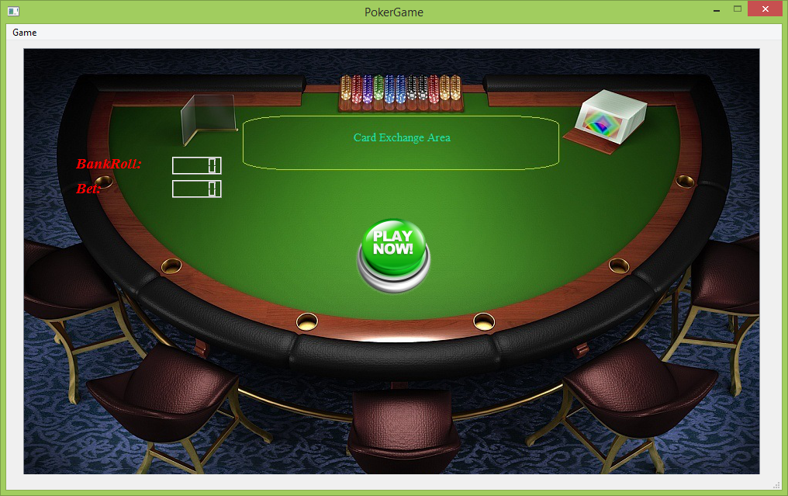

* + 1. After clicking Start Now! the player can choose a bet roll before playing the Poker:

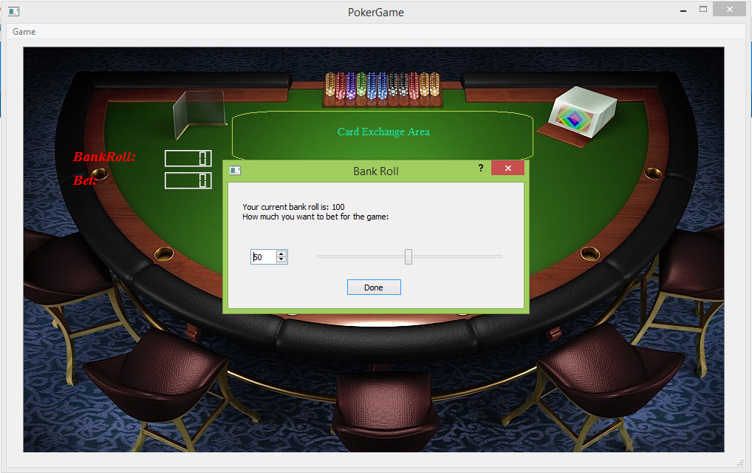

* + 1. The player gets the first five Poker cards:

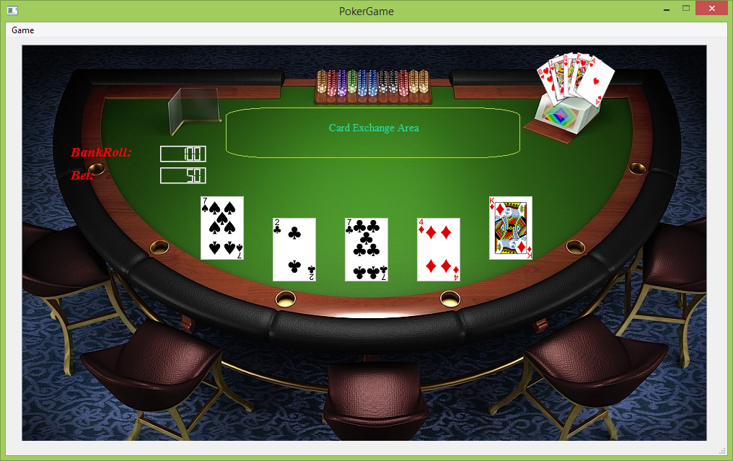

* + 1. The player chooses any number of the first five ones for replacing by moving the cards and then click on the animated button near the top right corner:

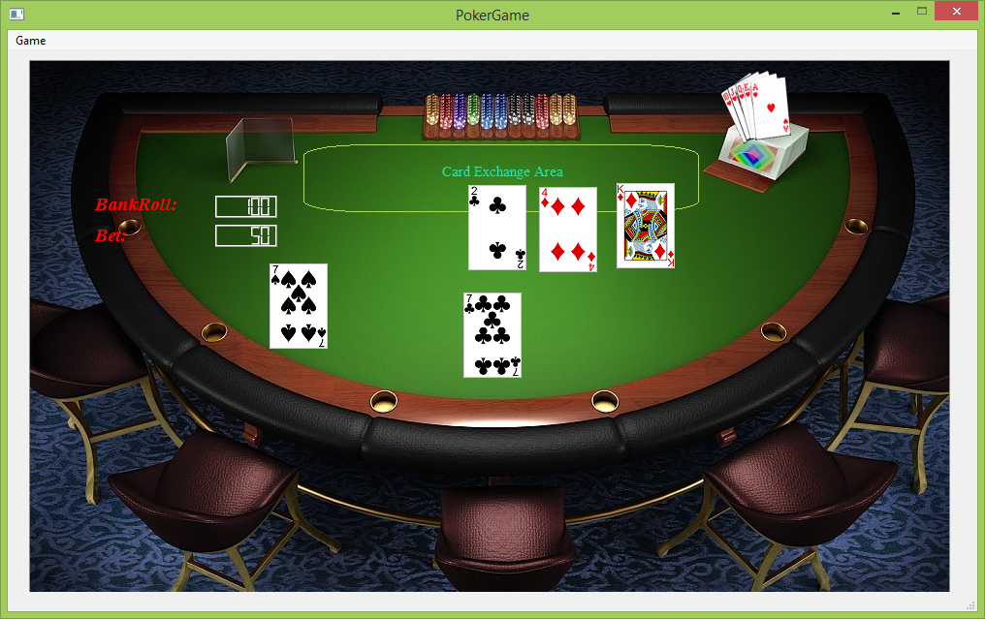

* + 1. The final result of Poker:

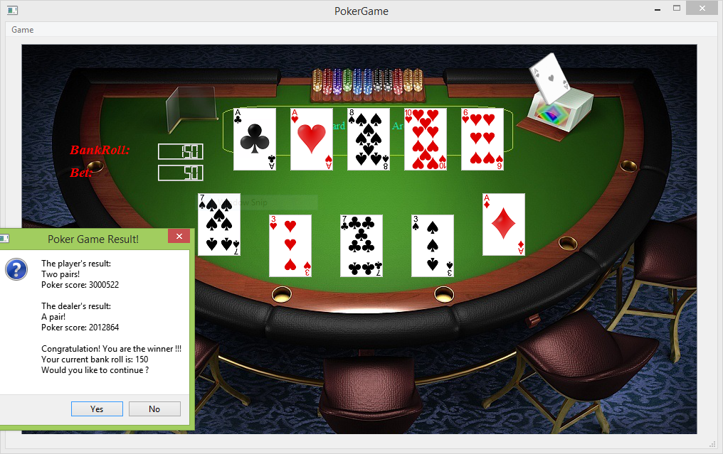

* + 1. The player continues on a new game:

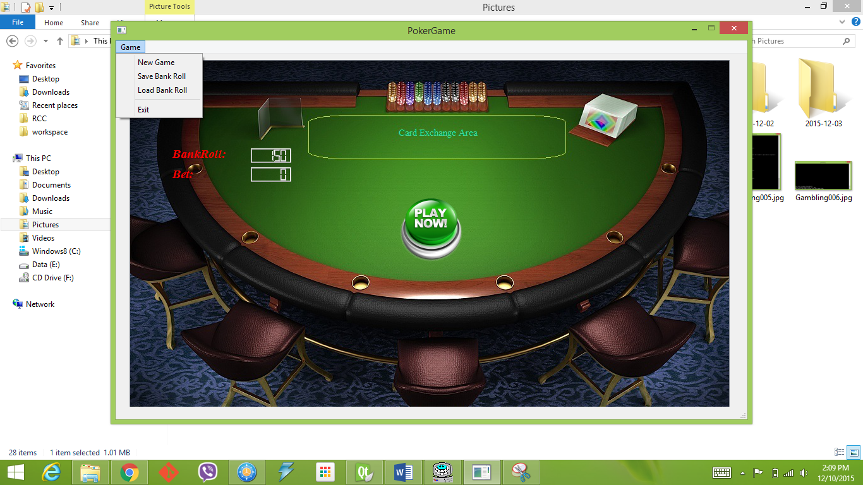

* + 1. The player choose the Load menu option:

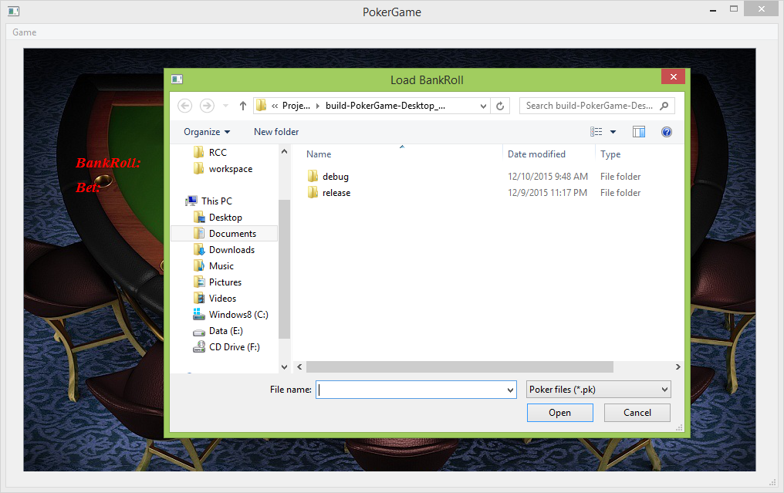

* 1. Flowchart and Pseudo code:
     1. Class design:
     2. Replace card flowchart.
  2. Variables:
  3. Concepts:

1. Program (Header File List):
   1. “bankroll.h”
   2. “mainscene.h”
   3. “mainwindow.h”
   4. “PokerCardTable.h”
   5. “pokerclient.h”
   6. “pokerhelper.h”
   7. “pokerpushbutton.h”
   8. “uicontroller.h”